CS415 Project 1 Report

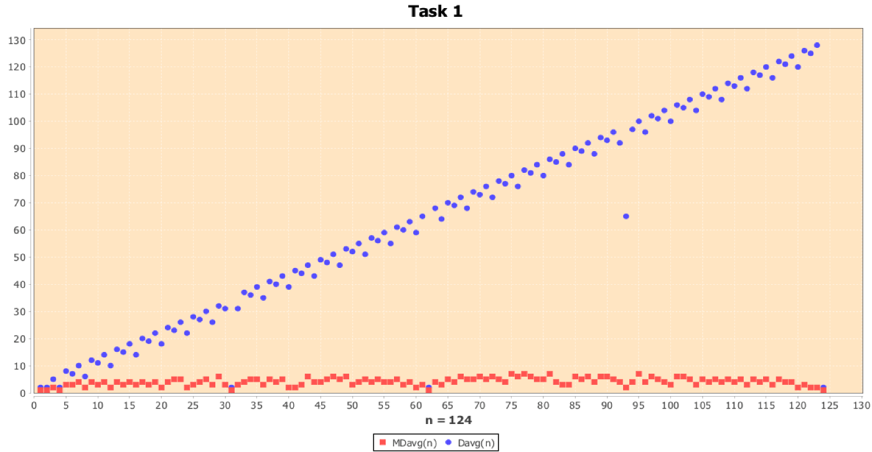Task 1 Report:

In the scatterplot above, in blue we have the number of Divisions in the average case, Davg(n), for the Consecutive Integer Checking method, and in red we have the number of Modulo Divisions done by Euclid’s algorithm. On the x-axis we measure the input, **n**, and on the y-axis we measure the number of divisions done. The values for each axis in this graph go from 1 – 125. The values of **n** plotted for each algorithm was each integer in the 1-125 range.

Graph Analysis:

While the values of the two axes are relatively small in the grand scheme of things, it’s big enough to see an immediate difference between the two algorithms. For the Consecutive Integer Checking algorithm we can see the plots of its values aggregate around a straight line, demonstrating a constant growth as the value of **n** increases. At n = 1 the algorithm makes 2 divisions on average and at n = 125 the algorithm makes around 130 average divisions. 2-130 is also the range of values of the graph. On the other hand, Euclid’s Algorithm’s average number of modulo divisions barely increases from the first n value (1) where the number of average divisions = 1, to the last n value measured (125), where the average number of divisions is roughly 2. From the graph we can see the plots from Euclid’s form a line that has minimal, if any, growth, that goes straight across the graph. The range of it’s values go from 1-8 and it’s very common for n to increase and the number of mod divisions to decrease.

From the shape and values of the Consecutive Integer Checking algorithm scatterplot we can determine that the algorithm’s average-case efficiency is most likely in **O(n)**, due to the linear growth of the divisions with the increase of n and the straight line that the plots form.

From the shape and values of the Euclid’s algorithm scatterplot we can determine that the algorithm’s average case-efficiency is most likely in **O(log n)**, due to how low the values are, though greater than 1.

*From this scatterplot we can extrapolate the values for the number of average divisions the two algorithms may take*, for values of n outside the range of the scatterplot. Below is a table with *predictions* made for every input, where n = 10k, for 1 ≤ k ≤ 5, as well the actual number of average divisions made by the algorithms, calculated by our program.

|  |  |  |
| --- | --- | --- |
| **Values of n** | **MDavg(n)** | **Davg(n)** |
| 10 | 1.8 | 5.5 |
| 100 | 3.57 | 51.75 |
| 1000 | 5.423 | 504.785 |
| 10000 | 7.3667 | 5009.3587 |

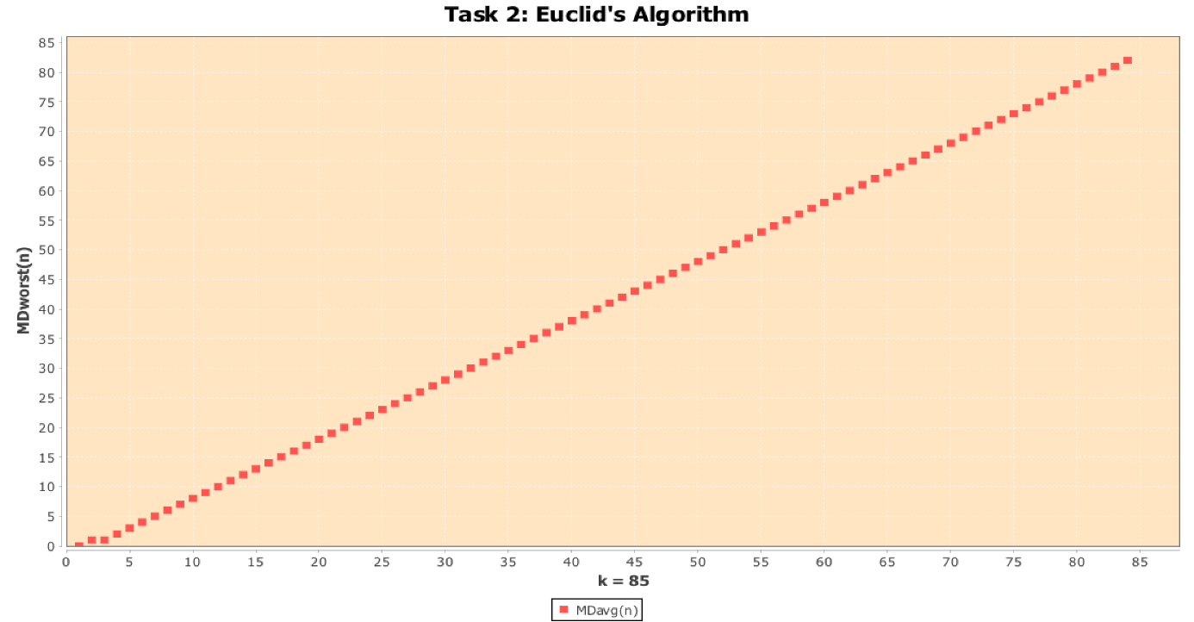Task 2 Report:

The scatterplot above shows the number of modulo division done in Euclid’s for each value of k, where m and n in gcd(m, n) is f(k + 1) and f(k). The x-axis measures the value of k, going from 1-84, while the y-axis measures the number of modulo divisions done in gcd(f(k+1), f(k)).

Because the application was written in Java using the BigInteger data type to compute the nth Fibonacci number and GCD using Euclid’s algorithm, there is no upper bound for k demonstrated in this case because BigInteger has no cap on its max size (as large as the RAM on the computer can hold).

**However, if the application were to use a primitive 32-bit signed binary integers to compute the nth Fibonacci number then the upper bound for k would be no greater than 46. This is because that k = 46 computes the value 1836311903 and k = 47 computes the value 2971215073, which is greater than the maximum possible value for a 32-bit signed binary integer 2147483647.**

From the scatterplot we can see the plots form a straight, that increases at a linear rate. The number of modulo divisions done at each k is almost equal to k. From the graph we can infer that the worst case efficiency class for Euclid’s Algorithm is **O(n)**, judging from the linear nature the plots aggregate to on the graph. This is a significant difference from the complexity of the average case efficiency class of Euclid’s which we determined to be **O(log n)** in Task 1.

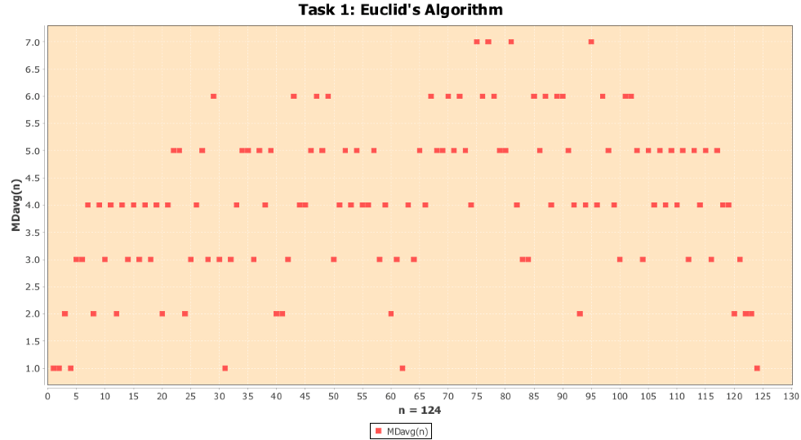This is the scatterplot from Task 1 without the Consecutive Integer Checking average number of divisions. There is a large difference in the range of the y-axis between this graph and the worst-case graph above, as the worst case modulo divisions go to far greater values. To show this difference we can look at the value where n = 89 for Task 1 and compare it with the Task 2 graph where k = 12 (due to 89 being the 12th Fibonacci number in the sequence). The value of Task 2 is 12 which is already almost 2x more than any value in the Task 1 graph for Euclid’s algorithm. It’s larger than even the value we computed with our program for n = 105 for Task 1 which was 7.3667. Again, we can see that the worst case of Euclid’s algorithm is significantly less efficient then it’s average case.

In this task we can also compare the actual time it takes. The table below shows values computed by our program, where k = multiples of 10 ≤ 80.

|  |  |
| --- | --- |
| **Value of k** | **Time (in nanoseconds)** |
| 10 | 36305.9 |
| 20 | 68692.5 |
| 30 | 98772.0333 |
| 40 |  |
| 50 |  |
| 60 |  |
| 70 |  |
| 80 |  |

Task 3:

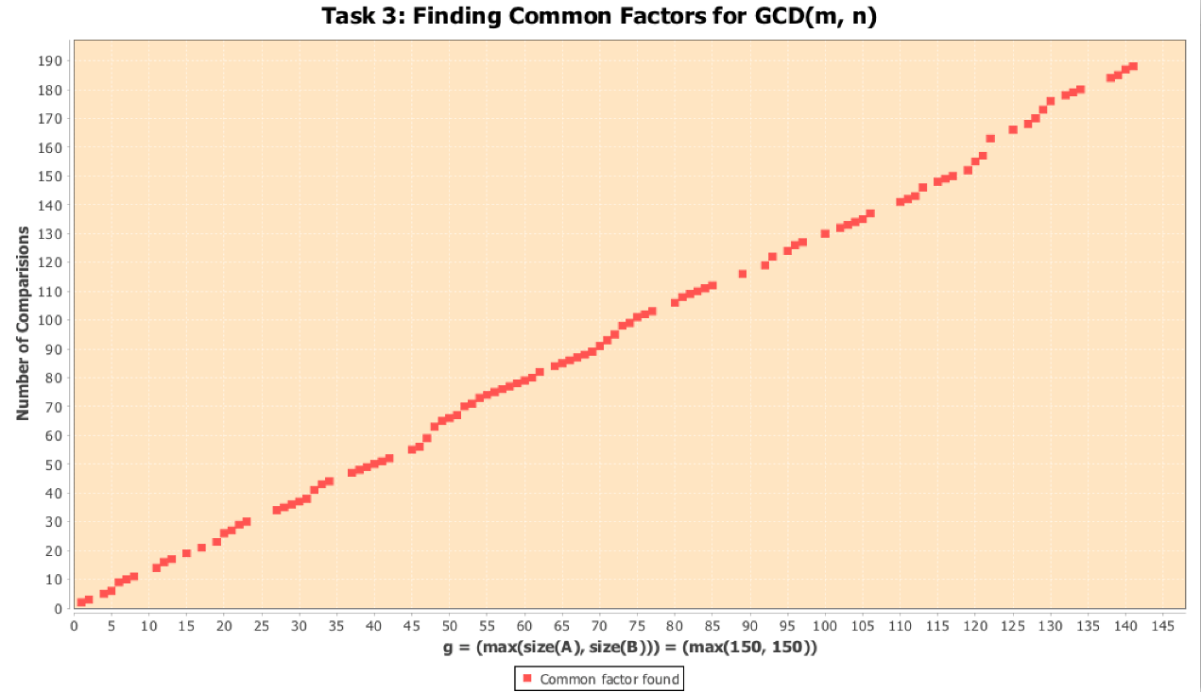

The scatter plot above shows the number of comparisons made when g = max(size(a), size(b)). The y-axis measures the number of comparisons while the x-axis is max(size(a), size(b)). The max values for A and B is 150 as that is the biggest size of prime numbers that the lists would hold. *The inputs measured are*

From how the plots in the graph are placed, we can see that the plots form in a relatively straight line, which shows a linear growth. The number of comparisons is practically equal to max(size(a), size(b)) and as max(size(a), size(b)) = g we can see that the Middle-school procedure is in Θ(g).

Report Rubric Requirements:

Task 1:

*Comparison between algorithms made.*

*Indicated clearly what values of n were used to generate scatterplot.*

*Scatterplot of MDavg(n) and Davg(n) and each algorithm’s likely average-case efficiency class provided.*

Task 2:

*(1) Upper bound of k*

*(2) Scatter plot showing number of modulo division as function of m*

*(3) worst-case efficiency class*

*(4) comparison made with average-case efficiency*

*(5) Analysis for actual time*

Task 3:

Showed that "common elements of sorted list" algorithm is Θ(n).

Indicated clearly what input was used to generate data for scatter plot.